**Srujana-The Watson Chatbot**

1. **Introduction**: Chatbots are the new, 24X7 face of customer service. Contact Centre needs to tap fully into this opportunity to leverage on customer service and innovation. This initiative is aligned with the Digital roadmap of the Bank and is a must in terms of disruptive technology.
2. **Objective**: The objectives behind implementing a Chatbot at Contact Centre are mainly:
   1. To help in effectively transfer the load of customer queries from Voice to non-voice channels (Website, Chat, IM, Social Media)...

The Chatbot should help in reducing the number of calls for basic but frequent queries. Basic

transactional queries should be tackled by a Bot. Ultimately, helping in reducing workload on Contact Centre and frontline CSR by roughly 25/30% (desired state).

To leverage on customer experience

The intent of implementing a Chatbot in Contact Centre is firstly to level up Customer Experience by allowing customers to interact with a Bot using the Chat window available on the website of the Bank in first place, Internet Banking interface or through JuiceByMCB mobile application in next phases.

* 1. To build and propose an interactive documentation platform to internal and external customers.

The Chatbot project initiative will help in effectively handling customer queries and built a platform for customer documentation leading to financial literacy.

* 1. About Watson: IBM Watson Assistant is a white label cloud service that allows enterprise-level software developers to embed an artificial intelligence (AI) virtual assistant (VA) in the software they are developing and brand the assistant as their own. The service, which gives consumers access to Watson AI , is delivered through the IBM Cloud.

Watson Assistant, which uses Watson AI machine learning (ML) and natural language understanding (NLU), is marketed to businesses that want to have the option of keeping the data that flows through their virtual assistant private.

1. **Technology:**
   1. **UI**:

* jQuery UI ,
* Bootstrap3
* HTML , CSS , JS
  1. **BackEnd**:
* Java 1.8
* Watson API
* IBM Cloud functions
* RESTful services( We can use java or any programming language )
* Ajax

1. **POC Use Case:**

We have created Support bot (Ms.Srujana) for bank account opening for users.

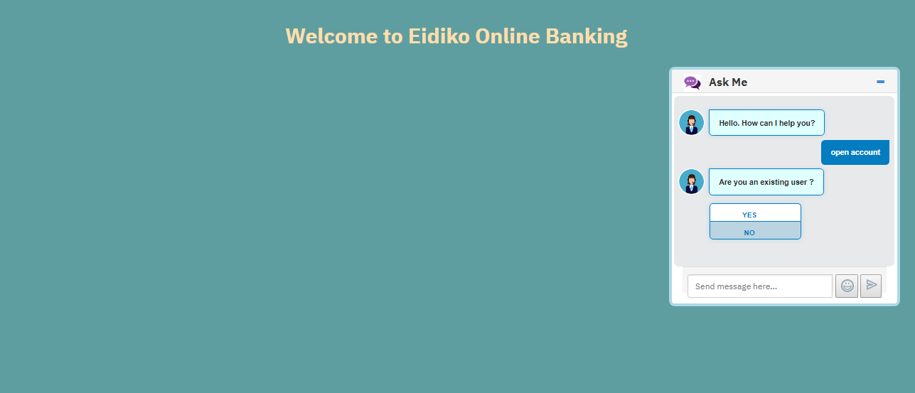

1. **Additional Features:**

* Validations: we can validate like e-mail and phone numbers.
* Expressions: To expand variable values inside other variables or invoke methods on properties and global objects, use the <? expression ?> expression syntax. EX: **Expanding a property:** "output":{"text":"Your name is <? context.userName ?>"}
* Search Skill: When Watson Assistant doesn't have an explicit solution to a problem, it routes the user question to a search skill to find an answer from across your disparate sources of self-service content. The search skill interacts with the IBM Watson™ Discovery service to extract this information from a configured data collection.
* Dialog Node: Ex:Condition:#operating_hours AND @sys_location=="Boston" TextResponse:"Our bank will open from 9am to 10pm"

1. **Project requirements:**

The intent of implementing a Chatbot at Contact Centre is to level up Customer Experience by allowing customers to interact with a Bot using the Chat window available to internal and external customers.

**Product Demographics**:

The Chatbot will help out operations by giving real-time responses to customer queries including employees. This solution can be taken up for training purposes of new comers and also may help in having access to real-time relevant information to be able to in turn inform external and internal stakeholders in a precise and timely manner.

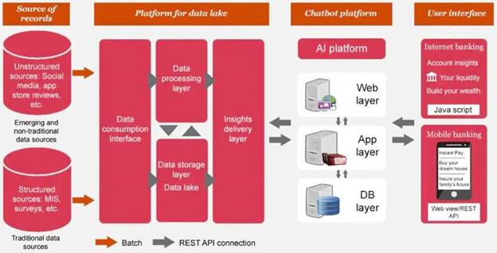

Call to Action

desired outcome

Push Strategy

There is a need for Contact Centre agents to get full and quick access to information. So if an employee needs to know what documents he needs to pick up from a customer, he can invoke the Chatbot to obtain the reply and even get the formats of documents that are needed and share them with the customer.

pull-through offer

Pull Strategy

Customers should be able to freely and easily have access to Chatbots on a 24/7 basis without having to wait for an agent interaction/ availability. How can Contact Centre operations tap into the trend?

Customer should be able to identify themselves as per their profile, preferences, services, procedures, language, and get self-served by using dynamic menus and messages

Process

List of Support Functionalities and Development

Continuous development of questions and answers to feed the Bot database in order to stay relevant and up to date. Below is a set of basic Q&A... as per zip file :

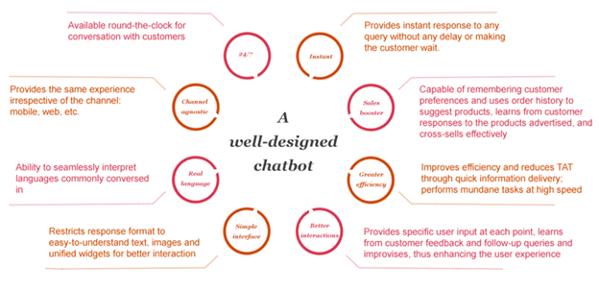

Prospecting Mechanism

Manageable routing

To consider the omnichannel strategy and how it is implemented in Genesys to feed the CRM. There is a need that all interactions with customers be it voice or non-voice be recorded on CRM as per below.

omnichannel_2

Pre-event Follow-up

Customer experience and flow

* Support Bot (Stage 1)

The support Bot should be able to reduce workload and mundane tasks while helping in answering queries (basic one to start with) thus allowing staff to be more focus on value added tasks such as cross-selling and upselling (face-to-face customer interactions for Frontliners)

* Sales Bot (Stage 2)

The Sales Bot should help to leverage on cross-selling and upselling opportunities. This can give a boost to customer interaction and conversation with the Bank. These non-structured data can later be taken into consideration to predict customer needs (at a later stage).

The Bot should be able to perform advisory once it is sufficiently smooth and able to run predictive analysis based on the transactional trend and pattern of the customer. [Forex, Investment, Loan campaigns, products and services... ]

* Feedback Bot (Stage 3)

This feedback Bot portal should be able to help the Bank to gather valuable feedback from customers and feed Marketing SBU regarding the CSI [Customer Satisfaction Index].

* Training Bot (Stage 4)

The Training Bot portal can be considered to bolster the training and teaching of our staff regarding processes, procedures, documentation and financial literacy at a larger scale [information related Finlease, Factors, Capital Markets, etc...]

* Complaint Management Bot (Stage 5)

The Bot should be able to handle complaints/ concerns from customers built on known cases and be able to reduce the number of complaints that need human intervention. The Everest database must be linked to the Bot Database for it to act upon the complaint and retrieve relevant resolution comments to formulate its answers. This Bot portal may be linked to the Feedback Bot portal, whereby customers choosing to rate MCB or give a feedback on their experience by accessing the Feedback Bot portal may afterwards want to log a complaint and get a resolution via the Complaint Management Bot portal.

What it may look like :

Below is a graphic representation of the 5 above mentioned solutions or Phases of the to-be Chatbot :

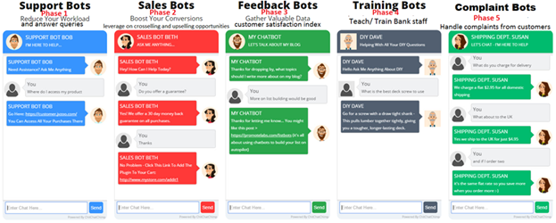

**Examples of Chatbot Usage**

Post-event Follow-up

Interact with the Bot flow to check relevancy of answers and interaction with user, thereby giving an indication of what could be the customer experience when rolled out. Perform UAT.

Feed the Bot Database on a regular basis with relevant information, answers and documentation.

Opportunity Criteria

0. Opportunities to integrate:

* Define a platform whereby the Bot could be trained and developed in order for it to answer to the requirements of the Business.
* Machine Learning and/or deep learning in order to automatically train the Bot. To define the update frequency of Database
* Intelligent conversation flow where Business could ask IT to intervene without having to wait for intervention of external service provider.
* Last agent feature and omnichannel strategy to be included to allow agent to shift from one channel to another while conversation is seamless for customer.
* Choice of a unified platform to put together all the required information to feed the Bot in terms of data optimization and relevancy.

1. Operational aspects (amongst others)

* Conversational French/ English/ Kreol language (possibility of switching language FR- EN/ EN- FR? )
* Switching from Bot to human and vice versa (this should be seamless for customer and end user )
* Authentication features (history logs to provide reference and advice to existing customers)
* Sentiment analysis (easier for voice, but also able to refer to complaints section for text)
* Take actions on behalf of customer (secured transaction through an authentication process) such as change of email address, mobile number, landline number through the Chatbot.
* Bot to perform advisory based on transactional trend and customers' behaviour/pattern (once sufficiently trained and service running smoothly)
* Bot to gather feedback from customers (stats to be exported in csv. xls files..etc)

2. Technical aspects (amongst others)

· Predictive analysis/analytics and interactive guidance to help customer be more self-served

· NLP once the Bot is sufficiently trained to provide customers with personalised information and answers

· Consider integration in the omnichannel of the Contact Centre and Genesys

· Chatbot to be able to feed the CRM

· Chatbot should be able to share documentation as attachment

· Supervisory stats

3. Additional Business needs :

· Have a Bot Master who will be the person responsible of the Bot

· Bot should be well educated but should not take too long for implementation

· KPIs for Bot:

o Unique Users

o Dialogues

o Transactions

o View

o Query per User

Metrics and Expectations

Be able to decrease number of human intervention and provide a 24/7 customer support platform to customers while delivering top notch customer service.

KPIs for BOT to be included but not limited to are:

a. Unique Users

b. Dialogues

c. Transactions

d. View

e. Query per User

1. **Glossary:**
   1. **NLP:** NLP refers to all systems that work together to handle end-to-end interactions between machines and humans in the preferred language of the human. In other words, NLP lets people and machines talk to each other “naturally”.
   2. **NLU:** NLU is actually a subset of the wider world of NLP. It helps in parsing unstructured inputs e.g. mispronunciations, swapped words, contractions, colloquialisms, and other quirks.
   3. **AIML:** AIML (Artificial Intelligence Markup Language) is an XML dialect for creating natural language software agents. It contains the basic rules which Natural Language Understanding (NLU) unit uses internally. It can be think of as a heart of the engine. The more rules we add in AIML – the more intelligent our Chatbot will be.
   4. **NLTK(tool):** The Natural Language Toolkit (NLTK) is a platform used for building Python programs that work with human language data for applying in statistical natural language processing (NLP).   
        
      It contains text processing libraries for tokenization, parsing, classification, stemming, tagging and semantic reasoning. It also includes graphical demonstrations and sample data sets as well as accompanied by a cook book and a book which explains the principles behind the underlying language processing tasks that NLTK supports.
   5. **API.AI:** When we started API.AI, our goal was to provide developers like you with an API to add natural language processing capabilities to your applications, services and devices. We’ve worked hard towards that goal and accomplished a lot partnering with all of you. But as we’ve taken a look at our work over the past year and where we’re heading, from new features like our  Analytics tool to the 33 prebuilt agents, we realized that we were doing so much more than just providing an API. So with that, we’d like to introduce Dialogflow – the new name for API.AI.
   6. **IBM Watson :** IBM Watson Assistant is a white label cloud service that allows enterprise-level software developers to embed an artificial intelligence (AI) virtual assistant (VA) in the software they are developing and brand the assistant as their own. The service, which gives consumers access to Watson AI , is delivered through the IBM Cloud. Watson Assistant, which uses Watson AI machine learning (ML) and natural language understanding (NLU), is marketed to businesses that want to have the option of keeping the data that flows through their virtual assistant private.
   7. **Jira webhook: Webhooks**. A **webhook** is a user-defined callback over HTTPS. You can use **Jira webhooks** to notify your app or web application when certain events occur in **Jira**. For example, you might want to alert your remote application when an issue has been updated or when sprint has been started.
   8. **Intent:**  An intent represents the purpose of a user's input, such as a question about business locations or a bill payment. You define an intent for each type of user request you want your application to support. The name of an intent is always prefixed with the # character. To train the dialog skill to recognize your intents, you supply lots of examples of user input and indicate which intents they map to.
   9. **Watson studio:** Watson Studio provides you with the environment and tools to solve your business problems by collaboratively working with data. You can choose the tools you need to analyze and visualize data, to cleanse and shape data, to ingest streaming data, or to create and train machine learning models.
   10. **Watson assistance:** IBM **Watson Assistant** is a white label cloud service that allows enterprise-level software developers to embed an artificial intelligence (AI) virtual **assistant**(VA) in the software they are developing and brand the **assistant** as their own.
   11. **Deep Learning:**Deep learning is actually a subset of machine learning. It technically is machine learning and functions in the same way but it has different capabilities. As the name suggests, artificial intelligence can be loosely interpreted to mean incorporating human intelligence to machines. Artificial intelligence is the broader concept that consists of everything from Good Old-Fashioned AI [(GOFAI)](https://en.wikipedia.org/wiki/Symbolic_artificial_intelligence) all the way to futuristic technologies such as deep learning.
   12. **Machine Learning:** Machine Learning(ML) can be explained as automating and improving the learning process of computers based on their experiences without being actually programmed i.e. without any human assistance. The process starts with feeding good quality data and then training our machines(computers) by building machine learning models using the data and different algorithms. The choice of algorithms depends on what type of data do we have and what kind of task we are trying to automate.
   13. **Cognitive learning (self learning):** When we say the word “learning”, we usually mean “to think using the brain”. This basic concept of learning is the main viewpoint in the Cognitive Learning Theory (CLT). The theory has been used to explain mental processes as they are influenced by both intrinsic and extrinsic factors, which eventually bring about learning in an individual.



1. **Additional Features:**

* Validations
* Expressions
* Search Skill
* Speech Recognition/Audio Support
* Chat history as logs

1. **Screenshots:**

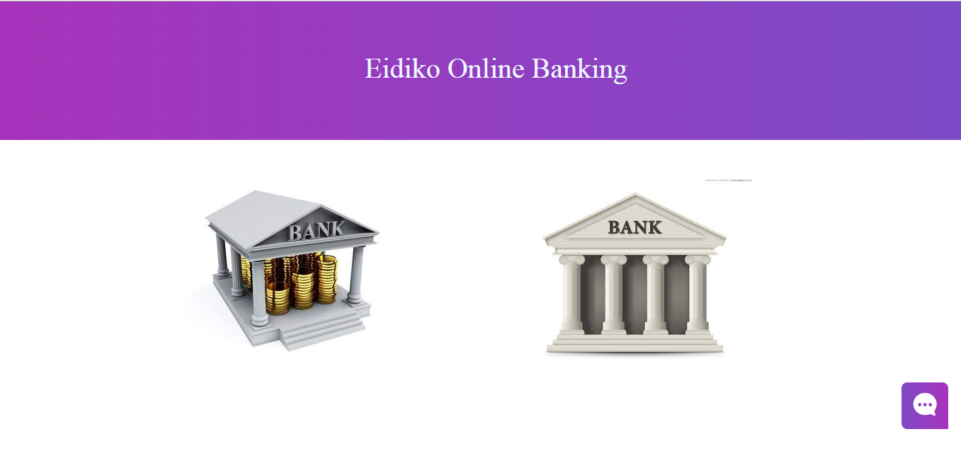

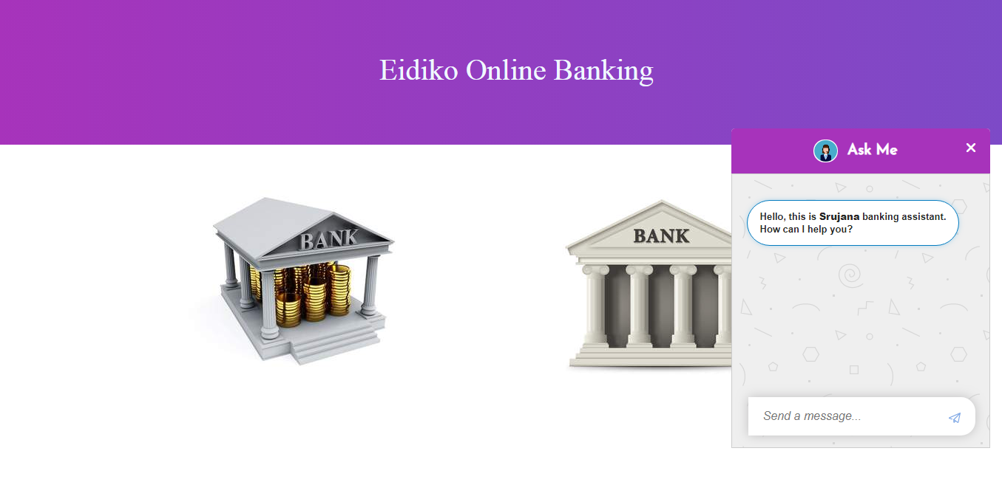

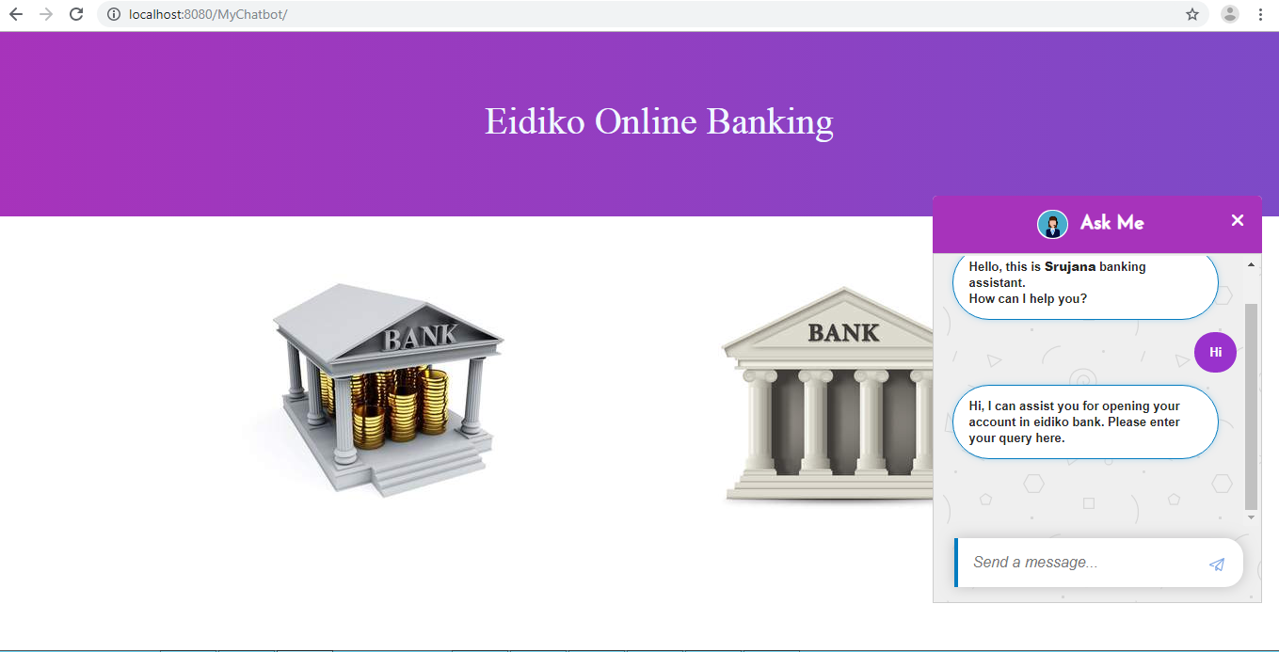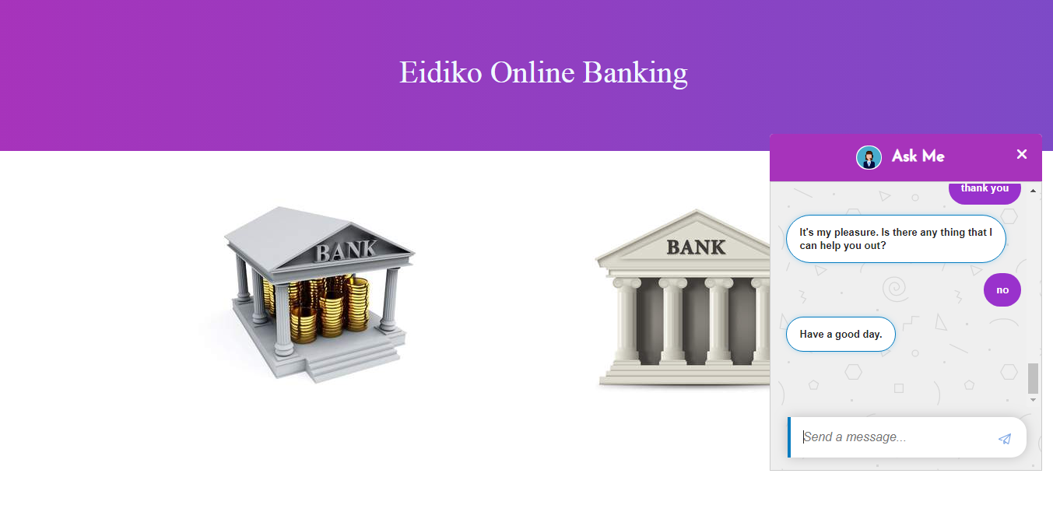

**\*\*\*\*\*\*\*\*\*\*\*\*\*\*\*\*\*End of Document\*\*\*\*\*\*\*\*\*\*\*\*\*\*\*\*\*\*\*\*\*\*\*\*\*\*\*\*\*\*\*\*\*\*\*\*\***